Feel free to customize this e-mail text to encourage your customers to participate.

Did you know that 9 out of 10 homes in the U.S. are under-insulated*? Sealing air leaks around your home and adding insulation can help you be more comfortable can save up to 11% on your home’s energy bills. The attic is where you can often find the greatest opportunities to increase energy efficiency. Do you know how your attic’s insulation level measures up? This heating season, take the first step by measuring your attic’s insulation, so you can “Rule Your Attic!”
From October 23 – November 17, 2017, the U.S. Environmental Protection Agency’s ENERGY STAR program will be sharing expert tips and resources to help you check your attic’s insulation level and take actions to enjoy a more comfortable, energy-efficient home.
Visit www.energystar.gov/ruleyourattic for links to expert advice and videos on how to check your attic insulation level. If you find low insulation levels, go to www.energystar.gov/sealandinsulate for do-it-yourself tips and suggestions for working with a contractor. You can even get personalized advice from EPA experts by sending pictures, videos, or questions to insulation@energystar.gov .
Why waste heat and money this winter? Rule Your Attic today!
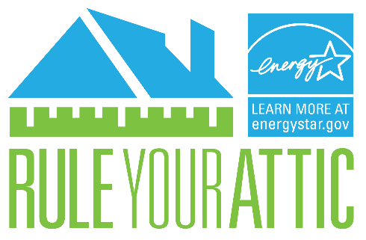

*Compared to 2006 IECC standards, Source: Boston University and NAIMA

